9 SCIENCE 2015

CHEMISTRY TEST ONE: THE ATOM

Name: ____________________ Mark: /61

Percentage: %

Table of common ions
Cations | Anions
+1 charge | - 1 charge
Hydrogen H⁺  Lithium Li⁺  Sodium Na⁺  Potassium K⁺  Copper (I) Cu⁺  Silver Ag⁺  Ammonium NH₄⁺ | Fluoride F⁻  Chloride Cl⁻  Bromide Br⁻  Iodide I⁻  Hydride H⁻  Hydroxide OH⁻  Nitrite NO₂⁻  Nitrate NO₃⁻
+2 charge | - 2 charge
Manganese Mn²⁺  Magnesium Mg²⁺  Calcium Ca²⁺  Barium Ba²⁺  Zinc Zn²⁺  Copper (II) Cu²⁺  Mercury (II) Hg²⁺  Iron (II) Fe²⁺  Tin (II) Fe²⁺  Lead (II) Pb²⁺  Nickel (II) Ni²⁺  Beryllium Be²⁺ | Oxide O²⁻  Sulfide S²⁻  Carbonate CO₃²⁻  Sulfate SO₄²⁻  Sulfite SO₃²⁻
+3 charge | - 3 charge
Aluminium Al³⁺  Iron (III) Fe³⁺  Boron B³⁺  Chromium Cr³⁺ | Nitride N³⁻  Phosphate PO₄³⁻  Phosphide P³⁻

Periodic Table

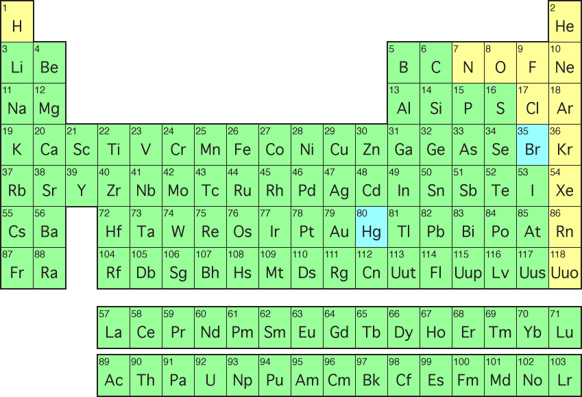

Multiple Choice Answer Sheet:

1. A B C D
2. A B C D
3. A B C D
4. A B C D
5. A B C D
6. A B C D
7. A B C D
8. A B C D
9. A B C D
10. A B C D
SECTION A: MULTIPLE CHOICE (10 marks)

Select the most correct answer for each question below.

1. The third electron shell of an atom can only hold:

(a) 18 electrons.
(b) 2 electrons.
(c) 8 electrons.
(d) 4 electrons.

2. To work out the number of neutrons in an atom:

(a) Take the atomic number from the mass number.
(b) Take the mass number from the atomic number.
(c) Add the mass number to the atomic number.
(d) Add the number of electrons to the number of protons.

3. How many of the known elements are found naturally on Earth?

(a) 87
(b) 94
(c) 79
(d) 91

4. The definition that best describes the word ‘element’ is:

(a) The fundamental building block of all materials.
(b) A substance made up of only one type of atom.
(c) A substance made up of two or more types of atoms.
(d) A metal that has many atoms.

5. H₂O (water) is an example of a/an:

(a) Element.
(b) Crystal lattice.
(c) Compound.
(d) Mixture.

6. When an atom loses electrons it forms a/an:

(a) Ion.
(b) Anion.
(c) Charged atom.
(d) All of the above.

7. The type of atom most likely to form a positively charged ion is:

(a) A metal.
(b) A non-metal.
(c) An atom with more protons than electrons.
(d) None of the above.

8. A cation is most likely to be formed when:

(a) An ion loses electrons.
(b) An atom loses electrons.
(c) The valence shell is full.
(d) All of the above.

9. How easily a compound dissolves is known as its:

(a) Crystallisation rate.
(b) Viscosity.
(c) Conductivity.
(d) Solubility.

10. An ionic compound is formed due to:

(a) The attraction of atoms with like charges.
(b) Two different types of atoms joining together.
(c) The attraction of atoms with opposite charges.
(d) All of the above.

SECTION B: SHORT ANSWER (51 marks)

1. State the difference between an element and a compound. (2 marks)

_______________________________________________________________________________________

_______________________________________________________________________________________

_______________________________________________________________________________________

_______________________________________________________________________________________
2. Label the diagram of the atom below. (2 marks)
Beryllium

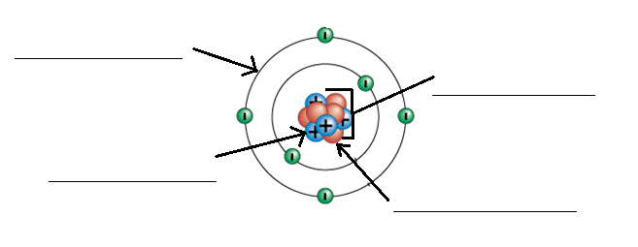
3. Follow the instructions below (draw neatly and in pencil). (4 marks)

a. In the box to the right draw a compound with three atoms.

b. In the box to the right draw a compound with two atoms.

c. In the box to the right draw an element with two atoms.

d. In the box to the right draw an example of a molecule.

4. Fill in the missing element names and symbols below. (7 marks)

ELEMENT | SYMBOL
Hydrogen
Helium
 | Be
 | B
 | N
 | O
 | Ne
Magnesium
 | Al
Silicon
Phosphorus
 | S
 | Cl
 | Ar

5a. Fill in the table below (use the table of common ions at the front to help you). (4 marks)

Ionic  formulae | Name of  metal  (cation) | Name of  non-metal  (anion) | Name of  compound
MgCO₃
NaI

b. Work out the ionic formulas in the table below (use the table of common ions to help you). (4 marks)

Compound | Working out | Ionic formula
Boron oxide
Iron (III) oxide
6. What subatomic particles are found in the nucleus of an atom? What is the charge of each?
(2 marks)

7. a. Which of the following are isotopes of the same element? (2 marks)

_____________ & ______________

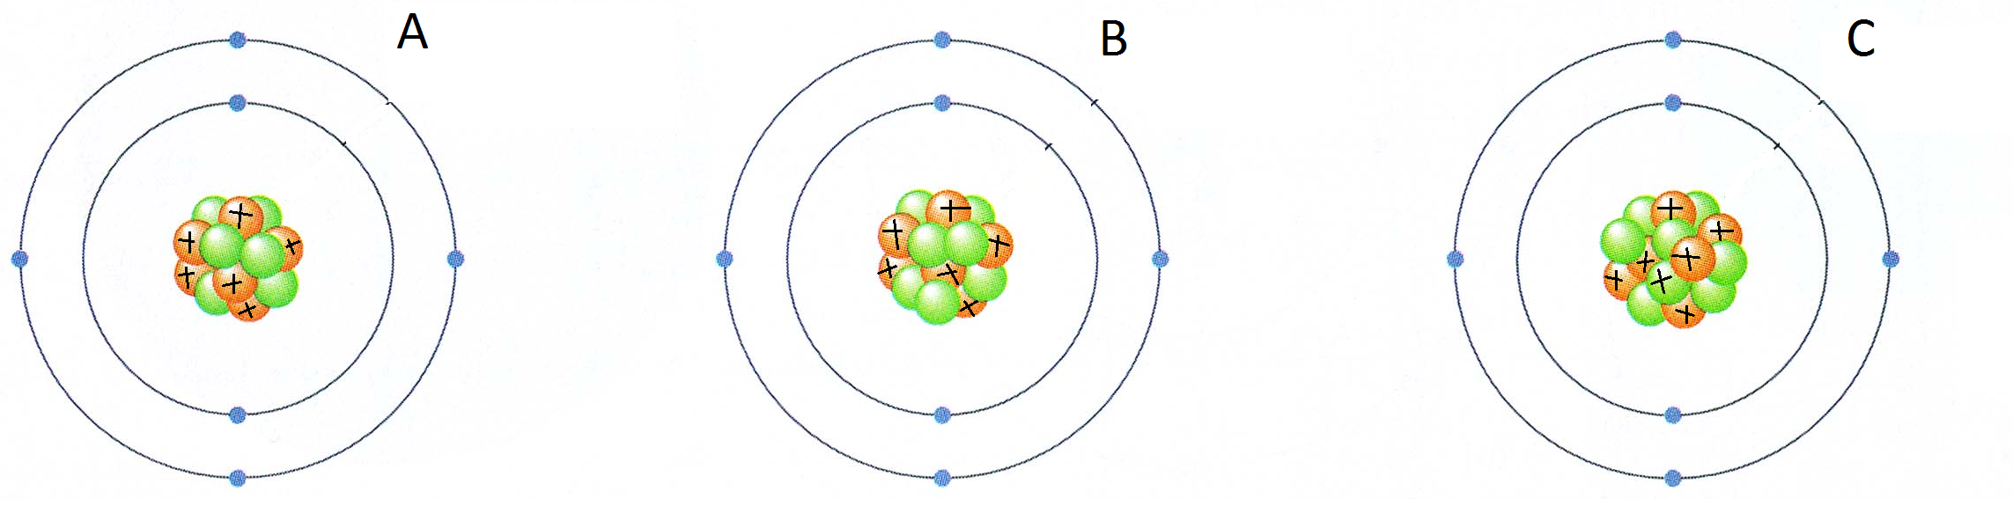

b. Which element has the two isotopes pictured above? _________________________

8. These questions all refer to the diagram below: (4 marks)
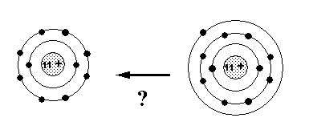

____________________ __________________

- What element is shown in the diagram above?
- Write the appropriate symbol beneath each diagram.

- What is different between the two diagrams?

- Did this change form an anion or a cation?
9. Write the term next to its matching definition below. (5 marks)

Electron shells, valence shell, atomic number, mass number, isotope

a) The number of protons and neutrons in the nucleus of an atom.

_________________________________________________

b) Atoms that have the same number of protons but a different number of neutrons in their nucleus.

_________________________________________________

c) The number of protons in the nucleus of an atom.

_________________________________________________

d) The outermost electron shell of an atom.

_________________________________________________

e) The layer/s that surrounds the nucleus and hold electrons.

_________________________________________________

10. Complete the electron configurations below (neatly in pencil). (4 marks)

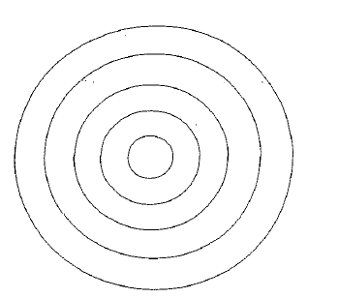
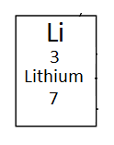
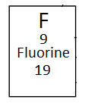

11. Determine the following for the element. (3 marks)

Number of protons: _________
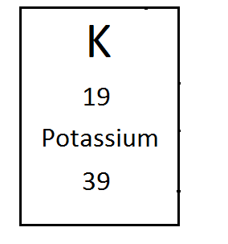
Number of electrons: _________

Number of neutrons: _________

Atomic number: _________

Mass number: _________

Element symbol: _________

12. Propose why atomic symbols are the same all over the world. (2 marks)

_______________________________________________________________________________________

_______________________________________________________________________________________

_______________________________________________________________________________________

_______________________________________________________________________________________

13. These questions refer to the diagram shown below. (3 marks)

a. What is the name of the type of structure shown?

b. What is the name of the type of bond found between each of the atoms?

c. What is the name of the compound shown below?

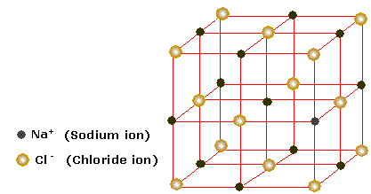

14. Read the information below then answer the questions. (3 marks)

An ionic compound is formed when a calcium ion (calcium is a metal) joins with an oxygen ion called oxide.

- Which of the above is the cation?
- Which of the above would have gained electrons to become an ion?

- What is the name of the compound formed?

